By the Light of the Silvery Moon by Gus Edwards and Edward Madden

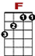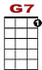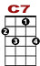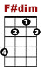
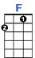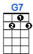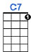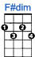
0
1 3 3 1 3 1 0 0
0 2 2 0 2 2 0 2 0
2 3 2
By the light of the sil ver y moon, I want to spoon. To my honey I'll croon love's tune.

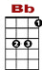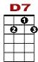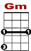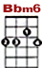
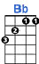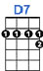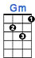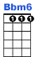
0 0 1 0 1 0
1 3 3 1 3 1 3
0 2
2 3
Honey moon, keep a shining in Ju- -u- -une. Your silv'ry beams will bring love dreams.

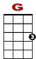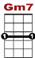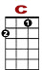
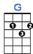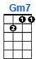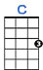
0 0
1 3 3 1 3 1 3 3 0 1

We'll be cud-dl-ing soon. By the sil ver y moon.

0
1 1 1 1 1 1 1 3 3 3 3 3 3 3 3
0 2
2 3
By the light (Not the dark, but the light) of the silvery moon Not the sun, but the moon)

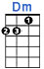

3 1 0 0 0 0 0 0
2 0 2 2 0 2 0
2
I want to spoon. (Not knife, but spoon) To my honey I'll croon love's tune.

0
1 1 1 1 1 1 1 1 3 3 1
0 2
2 3
Honey moon, (Not the sun, but the moon) Keep a-shining in June.

0 1 0 1 0 0
3 1 3 1 3 3 1 3 3 1 1 1 0

Your silvery beams will bring love dreams. We'll be cud-dl-ing soon (Not later but soon)

0 1 3 1 0 1

By the sil-ver-y moon.

