Bridge Over Troubled Water by Paul Simon

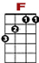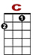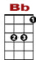

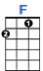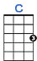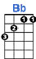
When you’re we-ar - y feel-in’ small, when tears are in your eyes,

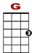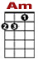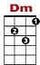

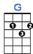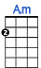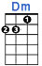
I’ll dry them all. I’m on your side. Oh, when times get

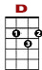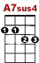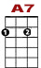

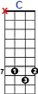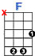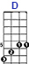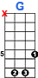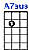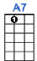
8

rough. And friends just can’t be found. Like a bridge over trou-bled wa-ter



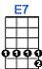

I will lay me down. Like a bridge ov-er trou bled wa-ter, I will lay me down.

2nd VERSE:

When you’re down and out, when you’re on the street,
When evening falls so hard, I will comfort you.
I’ll take your part, oh, when darkness comes, and pain is all around.
Like a bridge over troubled water, I will lay me down.
Like a bridge over troubled water, I will lay me down.

3rd VERSE:

Sail on silver girl, sail on by. Your time has come to shine.
All your dreams are on their way. See how they shine.
Oh, if you need a friend, I’m sailing right behind.
Like a bridge over troubled water, I will lay me down.
Like a bridge over troubled water, I will lay me down.

