Blue Skies by Irving Berlin

1st VERSE
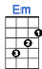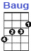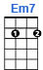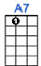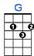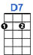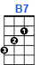
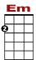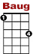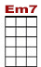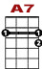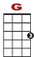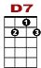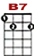
Blue skies ... smiling at me, nothing but blue skies ... do I see.

0 0 0
2 0 2 2 0 2 0
2 0 0 2

2nd VERSE
Bluebirds ... singin' a song, nothing but blue skies ... from now on.

0 0 0
2 0 2 2 0 2 0
2 0 0 2

BRIDGE
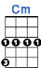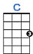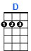
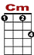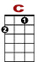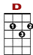
Never saw the sun shining so bright, never saw things going so right.

0 1 3 4 3 1 3 1 0 0
0 2 2 2 0 0
4

Noticing the days hurrying by, when you're in love, my, how they fly.

0 1 3 4 3 1 3 1 0 0
0 2 2 2 0
4 2

3rd VERSE

Blue skies ... smiling at me, nothing but blue skies ... do I see.

0 0 0
2 0 2 2 0 2 0
2 0 0 2

4th VERSE

Blue days … all of them gone. Nothing but blue skies....from now on.

0 0 0
2 0 2 2 0 2 0
2 0 0 2

