Blue Moon by Lorenz Hart & Richard Rodgers

VERSE 1:
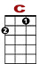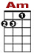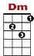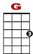
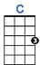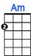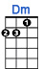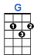
Blue moon, you saw me standing a-lone.

0
3 3 1 3 3 3 1 3

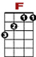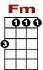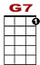
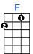 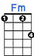 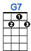
Without a dream in my heart, without a love of my own.

0
1 3 3 3 1 3 0
0 2 0 0 0
1
VERSE 2:

Blue moon, You knew just what I was there for.
You heard me saying a prayer for someone I really could care for.

BRIDGE:
And then there sud-den-ly ap-peared be-fore me. The on-ly one my heart could ev-ver hold;

0 0 0 2 2 2 0 2 2 0 0 0 0 0 2 2 2 0 2 2 0

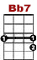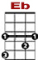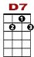
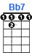 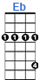 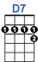 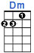
I heard somebod-dy whisper, "Please a-dore me." And when I looked, the moon had turned to gold.

3
0 0 0 0 0 0 0 2 2 2 2 2 2 2 2
3 3 3 3 3

VERSE 3:

Blue moon, now I'm no longer a-lone.

0
3 3 1 3 3 3 1 3

Without a dream in my heart, without a love of my own.

0
1 3 3 3 1 3 0
0 2 0 0 0
1

