Blackbird by The Beatles

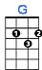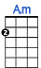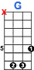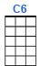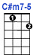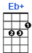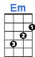

5 5 0 2 2 2 2 3 2
3 3 3 3 3 2 3 3 3

Blackbird singing in the dead of night, take these broken wings and learn to fly.
Blackbird singing in the dead of night, take these sunken eyes and learn to see.

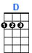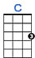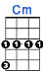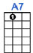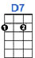

0 2 0 2 0 0 2 0
3 3 3 3 3 0 3 3

All your life, you were on - ly wai-ting for this moment to a - rise.
All your life, you were on - ly wai-ting for this moment to be free.

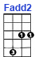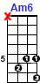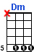

3 3 7 5 5
3 3 3 3 9 5 5 0 3
7

Black - bird fly, black - bird fly, in - to the light of the dark black night.

3 3 7 5 5
3 3 3 3 9 5 5 0 3
7

Black - bird fly, black - bird fly, in - to the light of the dark black night.

5 5 0 2 2 2 2 3 2
3 3 3 3 3 2 3 3 3

Blackbird singing in the dead of night, take these broken wings and learn to fly.

0 2 0 2 0 0 2 0
3 3 3 3 3 0 3 3

All your life, you were on - ly wai-ting for this moment to a - rise.

0 2 0 0 2 0
3 3 3 3 3 3
4

You were on - ly wai-ting for this moment to a - rise.

