Blackbird by The Beatles

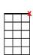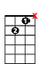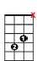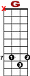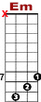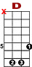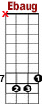

7 7 7 5 7 8 7
0 0 1 1 1 1 3 10 8 10 8
0 0 2 2 2 2 4

Blackbird singing in the dead of night, take these broken wings and learn to fly.
Blackbird singing in the dead of night, take these sunken eyes and learn to see.

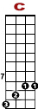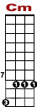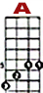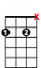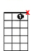
First verse only

5 7 7 5 5 5 5 7
8 8 8 8 10 8 5 3

All your life, you were on - ly wai-ting for this moment to a - rise.
All your life, you were on - ly wai-ting for this moment to be free.

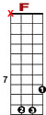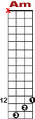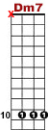

8 8 12 10
8 8 8 8 15 13 10 10 8
12 9

Black - bird fly, black - bird fly, in - to the light of the dark black night.

8 8 12 10
8 8 8 8 15 13 10 10 8
12 9

Black - bird fly, black - bird fly, in - to the light of the dark black night.

7 7 7 5 7 8 7
0 0 1 1 1 1 3 10 8 10 8
0 0 2 2 2 2 4

Blackbird singing in the dead of night, take these broken wings and learn to fly.

5 7 7 5 5 5 5 7
8 8 8 8 10 8 5 3

All your life, you were on - ly wai-ting for this moment to a - rise.

7 5 5 5 7
8 8 8 10 10 8 8
9

You were on - ly waiting for this moment to a-rise.

