Begin The Beguine by Cole Porter

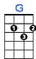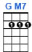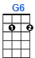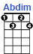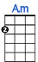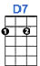
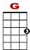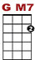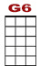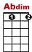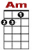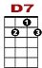
1
0 3 0 0 0 3 3 1 0 1
0 2 2 0 0 2 2

When they begin the beguine. It brings back the sound of music so ten - der.

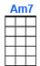
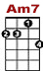
3 2 2 0 0
0 1 3 1 0 1 3 1 1 1 0
2 2 2 2

It brings back a night of tro-pi-cal splendor. It brings back a memory ever green.

1
0 3 3 0 0 0 3 3 1 0 1
0 2 2 0 0 0 2 2

I’m with you once more, under the stars, and down by the shore an orchestra’s play-ing.

3 2 0 0
0 1 3 1 0 1 3 1
2 2 2 2 0

And even the palms seem to be swaying when they begin the beguine.

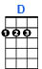
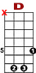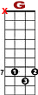
3 5 7 7 7 7 7 7 7 7 7
10 8

NO CHORD 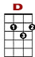
3 5 7 7 7 7 7 7 8 7 5 3 2
1

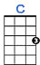
0 2 3 3 3 3 3 3 3 2 2 0 0
1 1 0 1 3 1
2 2 0

