As Time Goes By by Hoagy Carmichael

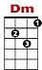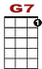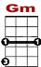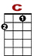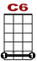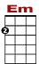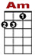
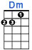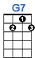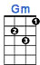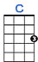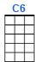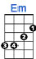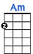

3 2 0 0
0 1 0 0 3 1 0 1 3 3
2 0 2 2

You must remember this, a kiss is still a kiss, a sigh is just a sigh.
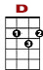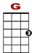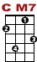
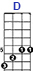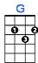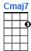

3 5
8 7 5 7 8 3 3 0
0 2

The fundamental things ap - ply as time goes by.

3 2 0 0
0 1 0 0 3 1 0 1 3 3
2 0 2 2

And when two lovers woo, they still say, “I love you,” on that you can rely.

3 5
8 7 5 7 8 3 3
0 2 0

No matter what the future brings, as time goes by.

BRIDGE:
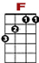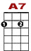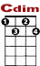
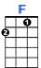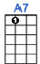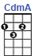
0 0 0 1 0 0 0 0 0 1 0 0
4 0 4
0 0 0 2 2

Moonlight and love songs, never out of date, hearts full of passion, jealousy and hate,
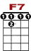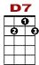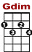
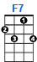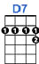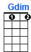
3 3 3 2 3 2 5 2 0 0
0 0 0 3 0
2

Woman needs man and man must have his mate, that no one can de -ny.

3rd VERSE:

Well, it’s still the same old story, a fight for love and glory, a case of do or die.
The world will always welcome lovers, as time goes by.
Oh, yes, the world will always welcome lovers, as time goes by.

