Angel From Montgomery by John Prine

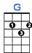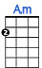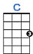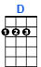
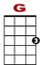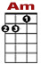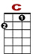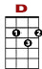

0 0 0 0 0 0 0 0
0 0 2 0 0 0 2 0 0 0 2 0 2 2 0

I am an old wo – man, named after my mo – ther, my old man is a - no – ther child that's grown old.

0 0 0 0 0
0 2 0 0 2 0

If dreams were light – ning, thunder was de – si – re,

0 0 0 0
0 0 2 0 0 2 2 0

This old house would have burnt down a long time a–go.

CHORUS:
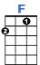
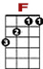

0 0 0 0 0 0 0
0 2 0 2 0 0 2 0 2 2
3 3 3 3 3
Make me an angel that flies from Montgom'ry. Make me a poster of an old ro – de – o.

0 0 0 0 0 0 0 0
0 2 0 2 0 0 0 2 0 0 0 0 2 2 0
3 3
Just give me one thing that I can hold on to. To believe in this liv – ing is just a hard way to go.

2nd VERSE:

When I was a young girl well, I had me a cowboy.
He weren't much to look at, just a free rambling man.
There was a long time and no matter how I try
The years just flow by like a broken down dam.
CHORUS:
3rd VERSE:
There's flies in the kitchen I can hear 'em there buzzing
And I ain't done nothing since I woke up today.
How the hell can a person go to work in the morning
And come home in the evening and have nothing to say.
CHORUS:

