Amazing Grace

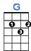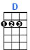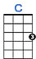
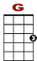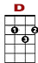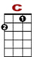

0 0 2 0 0 3 3
0 2 0 0 0 2 0
0 2 0 0
A-ma-z i n g grace, how sweet the sound, that saved a – a - a wretch like me.

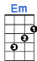
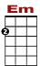

3 3 0 0 0 0
2 0 2 0 0 2 0 2 0
2 0 0
I once w - a - s lost, but now am found. Was blind, b – u - t now I see.

'Twas grace, that taught my heart to fear, and grace my fears relieved.
How precious did that grace appear, the hour I first believed.

The Lord has promised good to me, his word my hope secures.
He will my shield and portion be as long as life endures.

Through many dangers, toils and snares, I have already come.
'Tis grace hath brought me safe, thus far, and grace will lead me home.

When we've been there ten thousand years, bright shining as the sun,
we've no less days to sing God's praise, than when we first begun.

Amazing Grace, how sweet the sound, that saved a wretch like me.
I once was lost, but now am found, Was blind, but now I see.

