Always Words & Music by Irving Berlin, 1925

1st VERSE:
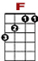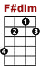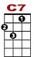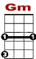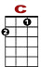
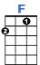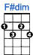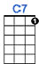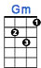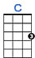

3 5 3 0 1 3 1 3 0
3 3
0 0 0

Ev'rything went wrong, and the whole day long I'd feel so blue.

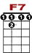
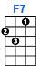

3 5 3 0 1 3 1 0
3 3 1
0 0 0

For the longest while, I’d forgot to smile, then I met you.

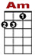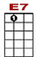
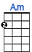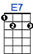

0 0 0 0 2 2 2 2 0 2 3
0 4 0

Now that my blue days have passed, now that I've found you at last …

CHORUS:

0 3 0 0
1 3 0 1 3 1
0 2 0 2

I'll be loving you, always, with a love that's true, always.

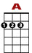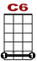
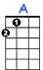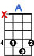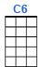

0 0 2 4 0 2 4 0 0
1 3 0 2 0 2 4 3
0 2

When the things you planned need a helping hand, I will understand, always, al - ways.

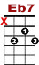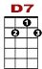
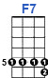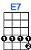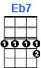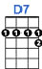

0 3 0 3 2 3 2 3 3 1
1 3
0 2

Days may not be fair, always; that’s when I’ll be there, al-ways.

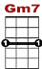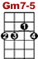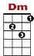
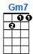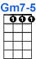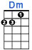

1 0 0 1 0 0 0
3 3 1 3 3 1 0 1 3 1
0

Not for just an hour, not for just a day, not for just a year, but always.

2nd VERSE:

Dreams will all come true, growing old with you and time will fly.
Caring each day more than the day before, ‘till spring rolls by.
Then when the springtime has gone then will my love linger on.

CHORUS:

