All Of Me by Gerald Marks and Seymour Simon, 1931

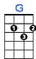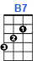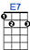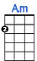

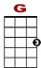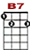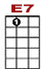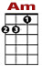

3 3 5 3 2 0 1 0
3 0 4 0 3 0 0 3 1
3

All of me, why not take all of me. Can't you see, I'm no good with-out you.

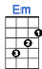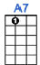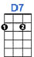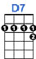

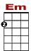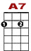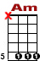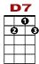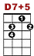

2 5 3 2 1 0 0 5 2
0 0 4 8 5
3 2

Take my lips, I want to lose them. Take my arms, I'll nev-er use them.

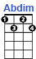

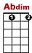

3 3 5 3 2 0 1 0
3 0 4 0 3 0 0 3 1
3

Your goodbye, left me with eyes that cry. How can I go on dear with-out you?

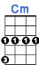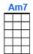
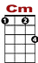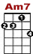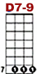

5 3 0 3 2 1 2 0 3 0 3 7 7 3
8 5

You took the part, that once was my heart, so why not take all of me.

All of me, why not take all of me. Can't you see, I'm no good without you.
Take my lips, I want to lose them. Take my arms, I'll never use them.
Your goodbye, left me with eyes that cry. How can I go on dear without you?
You took the best, so why not take the rest? Baby, take all of me.

