A Song For You by Leon Russell
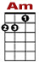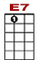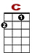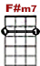
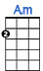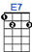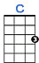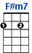
3 3 3 2 0 0 5 3 3 0 0
0 0 0 0 0
2 2 2 0 2
2
I’ve been so many places in my life and time. I’ve sung a lot of songs, I’ve made some bad rhyme.

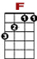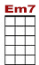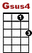
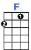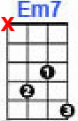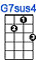
0 3 0 3 0 3 0 5 7 0 3 3 0 3 0 5 7

I’ve acted out my love in stages, with ten thousand people watching.

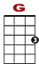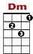
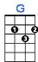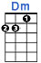
0
0 3 3 3
0 2 0 0 0 0
2 2
But we’re a-lone now and I’m sing - ing this song to you.

2nd VERSE:

I know your image of me is what I hope to be. I treated you unkindly, can’t you see,
There’s no one more important to me? Darling can’t you please see through me,
‘cause we’re alone now and I’m sing-ing this song to you.

BRIDGE:
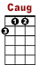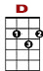
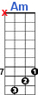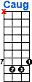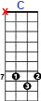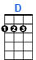
7 7 7 7 5 3
8 10 8 8 8 10
9 2 0

You taught me precious se-crets of the truth withhol-ding noth-thing.

0
0 3 3 3 0 0
0 0
2

You came out in front and I was hiding.

7 7 5 3 0
8 10 8 8 8 8 3 0
9 2 0

But now I’m so much bet-ter, and if my words don’t come to – ge - ther,

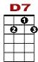
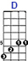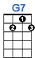
0 3 3 0 5 0 0 0 7 7 5 5 3 2
3

Listen to the melody cause my love is in there hid - ing.

3rd VERSE:

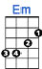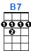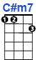
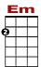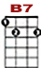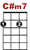

I love you in a place where there’s no space and time. I love you for in my life you are a friend of mine.
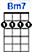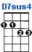

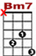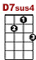

And when my life is over, remember when we were together,

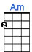

We were alone and I was singing this song to you.

